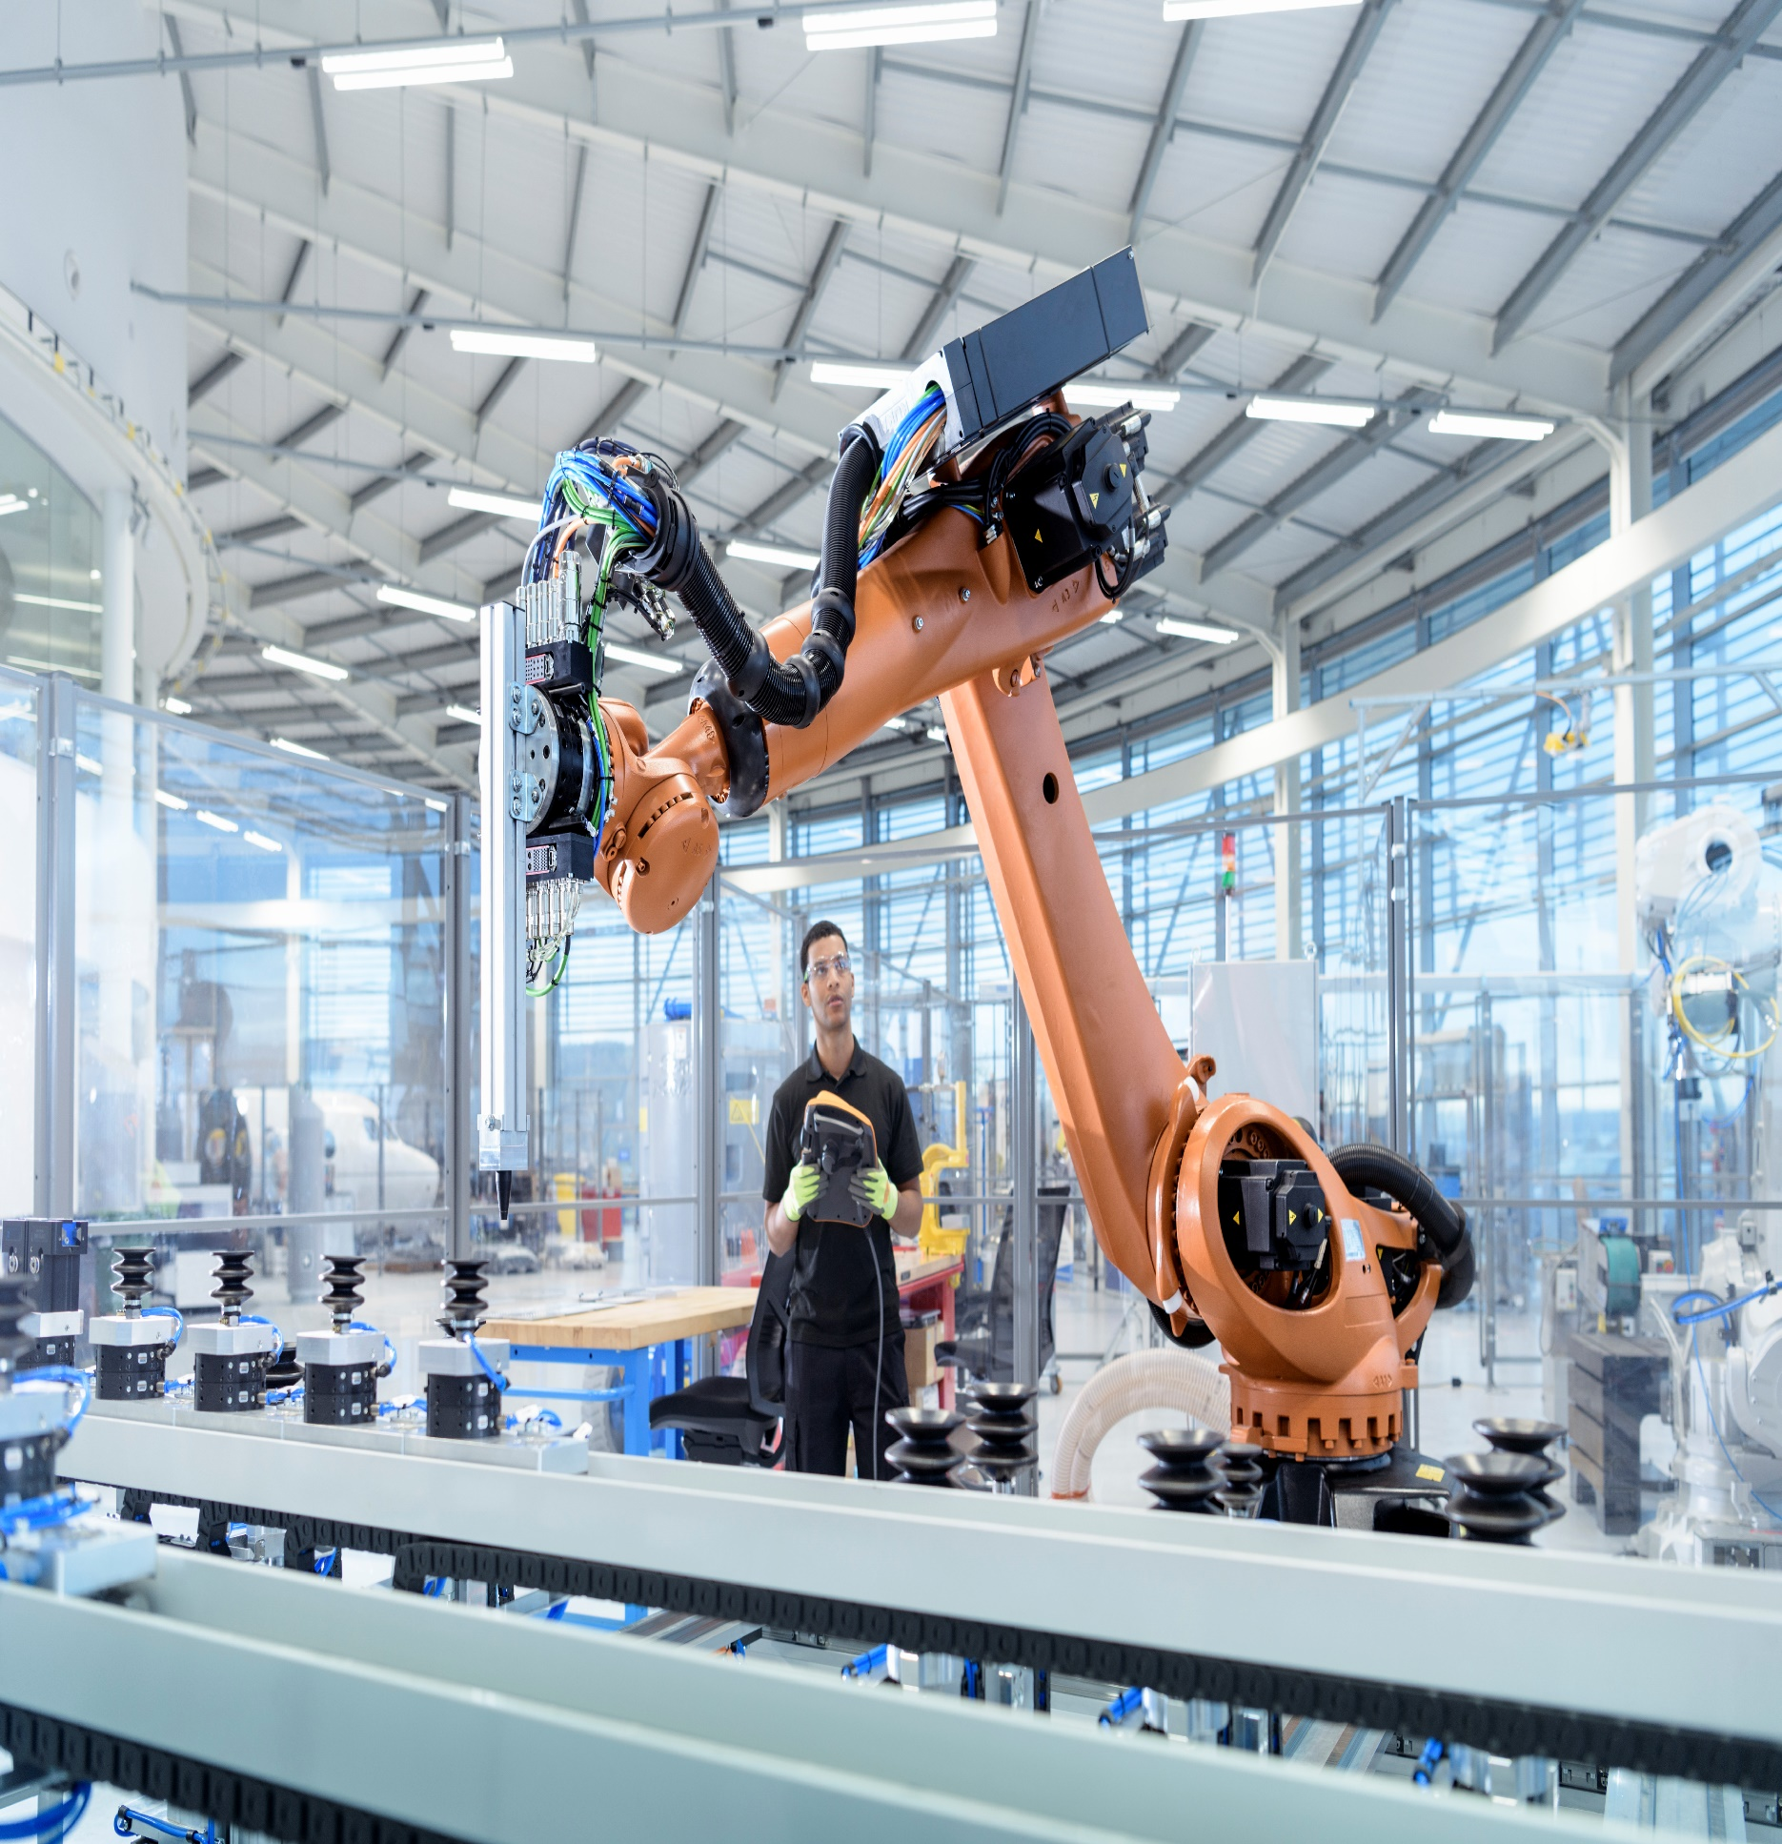

|  |
| --- |
| **Pneumonia Detection Challenge** |
| **Interim Report** |

|  |
| --- |
|  |
|  |
|  |

**Submitted By: Group 13**

|  |  |
| --- | --- |
| PRESENTED TO | Great Learning |
| PRESENTED BY | Group 13 – Aug C – Great Learning |
| DATE | 24 July 2020 |
| VERSION | 1.0 |

## Group 13 – Contacts

|  |  |  |
| --- | --- | --- |
| Name | Phone | Email |
| Sonal Sharma | +91 88102 64764 | [Sonal_1996@yahoo.com](mailto:Sonal_1996@yahoo.com) |
| Chandrashekar C | +91 98867 94586 | [chandrashekar.c@gmail.com](mailto:chandrashekar.c@gmail.com) |
| Susanta Mondal | +91 70440 55951 | Susanta.221285@gmail.com |
| Gopinath Bailur | +91 99400 78996 | [gbailur@gmail.com](mailto:gbailur@gmail.com) |

|  |  |  |  |
| --- | --- | --- | --- |
| CHANGE LOG | | | |
| DATE | VERSION | AUTHOR | CHANGE DESCRIPTION |
| 24th July 2020 | 1.0 | Group 13 | Initial Draft |
| 27th July 2020 | 1.1 | Group 13 | Updated based on the feedback with the mentor |

**Table of Contents**

1 Overview 4

2 Abstract 4

3 Project Objective 5

4 EDA Inference and Data pre-processing 6

5 Current Approach on Model building 16

6 Next steps and improvements. 20

# Overview

# Pneumonia is a form of acute respiratory infection that affects the lungs. The lungs are made up of small sacs called alveoli, which fill with air when a healthy person breathes. When an individual has pneumonia, the alveoli are filled with pus and fluid, which makes breathing painful and limits oxygen intake.

# Following are some of the key facts about Pnuemonia which needs at most attention to address the problem proactively.

* Pneumonia accounts for 15% of all deaths of children under 5 years old, killing 808 694 children in 2017.
* Pneumonia can be caused by viruses, bacteria, or fungi.
* Pneumonia can be prevented by immunization, adequate nutrition, and by addressing environmental factors.
* Pneumonia caused by bacteria can be treated with antibiotics, but only one third of children with pneumonia receive the antibiotics they need.

# Per WHO, Pneumonia is the single largest infectious cause of death in children worldwide. Pneumonia killed 808 694 children under the age of 5 in 2017, accounting for 15% of all deaths of children under five years old. Pneumonia affects children and families everywhere, but is most prevalent in South Asia and sub-Saharan Africa. Children can be protected from pneumonia, it can be prevented with simple interventions, and treated with low-cost, low-tech medication and care.

# The WHO and UNICEF integrated Global action plan for pneumonia and diarrhoea (GAPPD) aims to accelerate pneumonia control with a combination of interventions to protect, prevent, and treat pneumonia in children with actions to:

* protect children from pneumonia including promoting exclusive breastfeeding and adequate complementary feeding.
* prevent pneumonia with vaccinations, hand washing with soap, reducing household air pollution, HIV prevention and cotrimoxazole prophylaxis for HIV-infected and exposed children.
* treat pneumonia focusing on making sure that every sick child has access to the right kind of care -- either from a community-based health worker, or in a health facility if the disease is severe -- and can get the antibiotics and oxygen they need to get well;

# Based on research we have made an attempt to look at the Chest Radiography to identify the Lung Opacity and quickly help Clinical specialists to take right decisions to drive proactive measure to cure and help avoid the spread of this decease to larger extent.

# Abstract

This project is aimed at detecting Pneumonia by locating the lung opacities on the Chest radiographs. This process can help identify the problem at an early stage as well as helps the Clinical analysis much faster and drives better decision making. This process of Pneumonia detection will be done by looking at several thousand images of Chest radiographs taken from past wherein the analysis and desired results were identified by the specialists. These past datapoints will become the indicators and these images will be processed through the Computer Vision Technology of deep learning to capture every details by which a Deep Learning Algorithm will be built.

The new patients data will be fed to this model which detects the Lung Opacity indication along with its location such that Clinical specialists will be able to confirm diagnosis quickly and can help in taking respective decisions quickly to move forward with the next steps of the treatment.

Deep neural networks models have conventionally been designed and experiments were performed upon them by human experts in a continuing trial and error method. This process demands enormous time, knowhow and resources. To overcome this problem, a novel but simple model is introduced to automatically perform optimal classification tasks with deep neural network architecture .

The Neural network architecture was specifically designed for Pneumonia image classification tasks. The proposed technique is based on the CNN algorithm, utilizing set of neurons to convolve on a given sample images to extract relevant features from them. This is demonstrated through validating the accuracy of the detection along with the objective to reduce the loss while the network is learning the details.

As part of this project, we will be demonstrating the outcome with 4 different model architecture along with their outcome in each of the model and provide the commentary for each of the models developed.

# Project Objective

The objective of this capstone project is to build a Pneumonia detection system to locate the position of the inflammation in a Chest Radiography.

Based on the dataset provided, we will have to do the following steps to work towards building the final model and validate and results.

* Validate the images and respective bounding box coordinates.
* Extract all the features from the images and build the csv file for processing further.
* Perform Exploratory Data Analysis to validate all the data points and build insights
* Based on the project objective – isolate the dataset and accordingly images as well which are fully unique by removing the duplicate records in the dataset based on target variable.
* Build the model with different architectures and showcase the accuracy and showcase the right model to approach the problem description

# EDA Inference and Data pre-processing

|  |
| --- |
|  |

1. Based on the sample dataset provided – we see that there are 3 class values present..

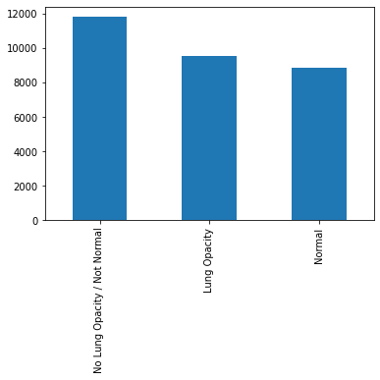

Our objective would be look at images having Lung Opacity and identify the right bounding box to locate the area of inflammation, hence we may need to club them into Lung Opacity and others as another single category

1. Post merging both the documents – class information with the labels document we see the following distribution on the “Target” variable

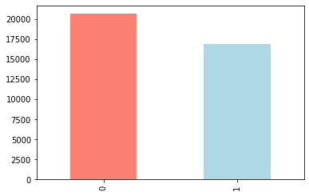

We observe there are more records not having lung opacity issues, which may lead to bias.

1. We observe the following heat map making the visualization where in the Target = 1

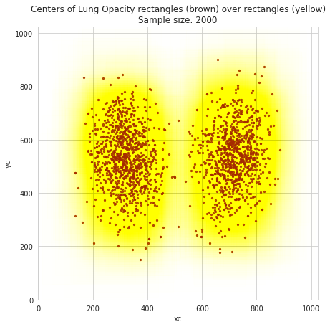

The scatter plot with brown dots shows the areas of inflammation highlighted which needs to be learnt to identify the issues.

1. Following are set of Metadata that we are able to notice from each of the chest X-ray’s provided..

Dataset.file_meta -------------------------------

(0002, 0000) File Meta Information Group Length UL: 202

(0002, 0001) File Meta Information Version OB: b'\x00\x01'

(0002, 0002) Media Storage SOP Class UID UI: Secondary Capture Image Storage

(0002, 0003) Media Storage SOP Instance UID UI: 1.2.276.0.7230010.3.1.4.8323329.28530.1517874485.775526

(0002, 0010) Transfer Syntax UID UI: JPEG Baseline (Process 1)

(0002, 0012) Implementation Class UID UI: 1.2.276.0.7230010.3.0.3.6.0

(0002, 0013) Implementation Version Name SH: 'OFFIS_DCMTK_360'

-------------------------------------------------

(0008, 0005) Specific Character Set CS: 'ISO_IR 100'

(0008, 0016) SOP Class UID UI: Secondary Capture Image Storage

(0008, 0018) SOP Instance UID UI: 1.2.276.0.7230010.3.1.4.8323329.28530.1517874485.775526

(0008, 0020) Study Date DA: '19010101'

(0008, 0030) Study Time TM: '000000.00'

(0008, 0050) Accession Number SH: ''

(0008, 0060) Modality CS: 'CR'

(0008, 0064) Conversion Type CS: 'WSD'

(0008, 0090) Referring Physician's Name PN: ''

(0008, 103e) Series Description LO: 'view: PA'

(0010, 0010) Patient's Name PN: '0004cfab-14fd-4e49-80ba-63a80b6bddd6'

(0010, 0020) Patient ID LO: '0004cfab-14fd-4e49-80ba-63a80b6bddd6'

(0010, 0030) Patient's Birth Date DA: ''

(0010, 0040) Patient's Sex CS: 'F'

(0010, 1010) Patient's Age AS: '51'

(0018, 0015) Body Part Examined CS: 'CHEST'

(0018, 5101) View Position CS: 'PA'

(0020, 000d) Study Instance UID UI: 1.2.276.0.7230010.3.1.2.8323329.28530.1517874485.775525

(0020, 000e) Series Instance UID UI: 1.2.276.0.7230010.3.1.3.8323329.28530.1517874485.775524

(0020, 0010) Study ID SH: ''

(0020, 0011) Series Number IS: "1"

(0020, 0013) Instance Number IS: "1"

(0020, 0020) Patient Orientation CS: ''

(0028, 0002) Samples per Pixel US: 1

(0028, 0004) Photometric Interpretation CS: 'MONOCHROME2'

(0028, 0010) Rows US: 1024

(0028, 0011) Columns US: 1024

(0028, 0030) Pixel Spacing DS: [0.14300000000000002, 0.14300000000000002]

(0028, 0100) Bits Allocated US: 8

(0028, 0101) Bits Stored US: 8

(0028, 0102) High Bit US: 7

(0028, 0103) Pixel Representation US: 0

(0028, 2110) Lossy Image Compression CS: '01'

(0028, 2114) Lossy Image Compression Method CS: 'ISO_10918_1'

(7fe0, 0010) Pixel Data OB: Array of 142006 elements

1. Of the above metadata – basis the observation of key fields names and its values, we decided to consider following metadata to form the CSV file for validating and processing further..

* 'patientId'
* 'Modality'
* 'PatientAge'
* 'PatientSex'
* 'BodyPartExamined'
* 'ViewPosition'
* 'ConversionType'
* 'Rows'
* 'Columns'
* 'PixelSpacing'

1. Processing the dicom images, we see the following

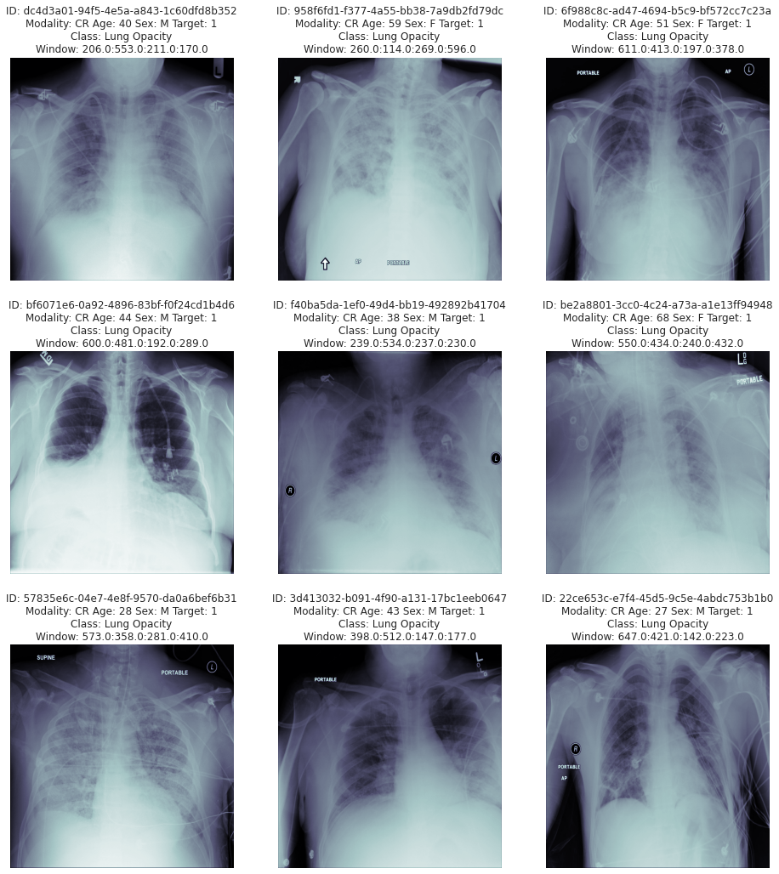

We observe all the images are 1024/1024 shape and it needs to be reshaped before feeding them into the model.

Based on the processed CSV file from the metadata – EDA was performed on this and below are the findings and also pre-processing steps taken to perform the data analysis

* EDA performed on the data taken out from each of parameters extracted from the images and clubbed against their patient ID's to validate them for its accuracy, impact based on availability of information overall. Below are some of the key findings.
* There are totally 37,629 records available in the dataset where in 16 fields were extracted for validation
* For Pnuemonia detection - "Target" Field provides the classification. 0 : No Lung Opacity, 1 : Lung Opacity

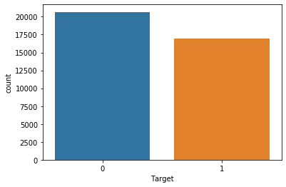

* "class" Field provides 3 groups. However when its seen against Target classification and respective coordinates availability - its doesn't seems to isolate between Normal and Not Normal cases. There are may be other problems, for the purpose of this exercise this observation will be ignored
* "Target" has 20,672 records/images which are Not having Lung Opacity and 16,957 having lung Opacity. We observe 55% of the images doesn't have lung opacity and only 45% having Lung Opacity - This may create imbalance in prediction tending towards not having Lung Opacity - Need to observe this furhter for duplicate records and plan for data augmentation
* "PatientAge" - We observe 5 records having ages above 100 - which should be dropped

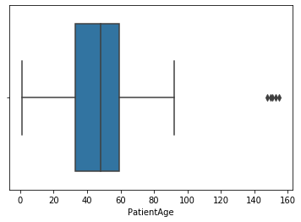

* "PatientSex" - We observe 55% of male records in the total count. This may not be a factor for recognition hence decided to continue even though there is imbalance..

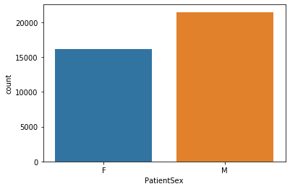

* We observe 9555 records are unique - which needs to be considered for model building
* For processing further – we have taken the ROWS having Target = 1, we found that there are 16K records
* Post processing for Duplicate records – we see that the record count comes to 9555 records..

1 9555

Name: Target, dtype: int64

* Of the 9555 records – below is the distribution on M / F

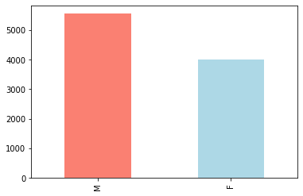

Since Male records are more – this may create data imbalance even though it may not be crucial at this time this needs to be validated.

* With the column “ViewPosition” we notice the below findings..

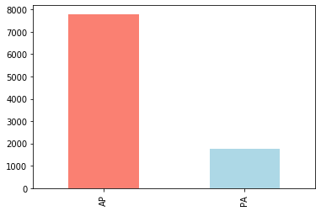

### With respect to Column "ViewPosition" correlated with the Target value of 1 - There is high imbalance that we observe with the above information having AP (Anterior-Posterior). One way to interpret this target unbalance is that patients that are imaged in an AP position are those that are more ill, and therefore more likely to have contracted pneumonia. Note that the absolute split between AP and PA images is about 50-50, so the above consideration is extremely significant

* Validating the target with age group – we observe the below pattern.

PatientAge count

0 0-10 219

1 11-20 602

2 21-30 1308

3 31-40 1591

4 41-50 1675

5 51-60 2226

6 61-70 1313

7 71-80 518

8 81-90 100

9 91-100 3

10 more than 100 0

Between age from 21 to 70 – The problem is highly detected and specifically 51 to 60 has more occurrence. We also observe some of the outlier which may needs to be dropped.

* We were able to extract and visualize the diacom images provided and visual representation are detailed below.

**RAW Images:**

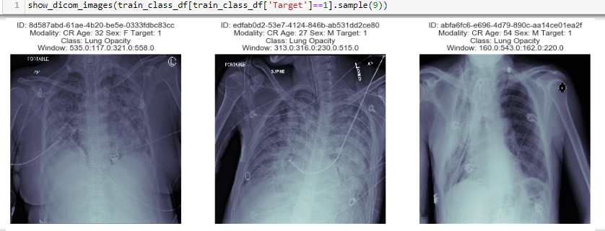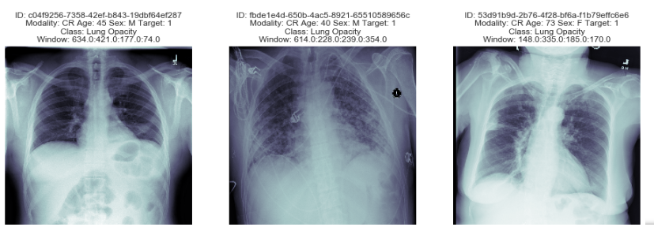

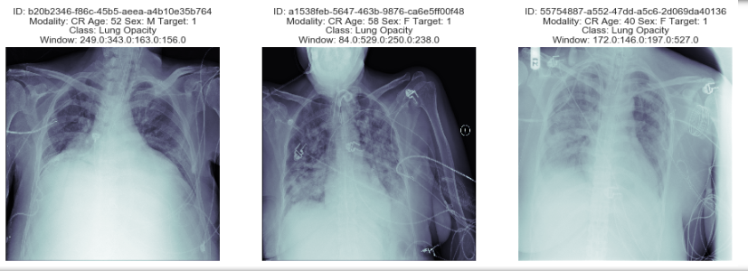

**RAW Images along with its bounding boxes (for the same samples above):**

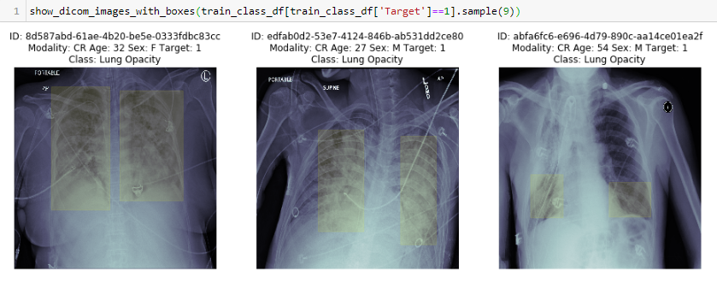

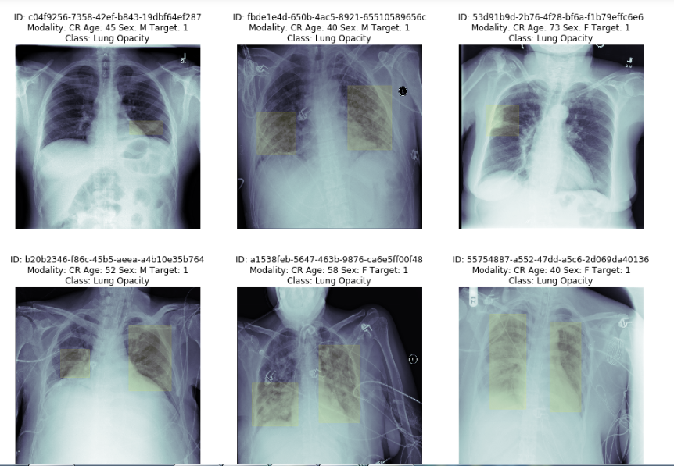

* Post this process as part of pre-processing we also associated the proper labelling for the respective images identified for processing further, we also validated this against the total records of 9555 to make sure that images along with associated labels are properly matched.

# Current Approach on Model building

Deep neural networks models have conventionally been designed and experiments were performed upon them by human experts in a continuing trial and error method. This process demands enormous time, knowhow and resources. To overcome this problem, a novel but simple model is introduced to automatically through CNN models.

We also noted that constructing and training a complex deep learning model from scratch is mostly infeasible due to the lack of hardware infrastructure. Therefore, we decided to exploits the idea of transfer learning which is the improvement of learning in a new prediction task through the transfer of knowledge from a related prediction task that has already been learned. This will improve the current computer vision methods based on the use of deep learning to diagnose X-rays images more effectively. By utilizing convolutional neural networks re-trained with our obtained data, we would like to experiment them to achieve the greater classification accuracy.

We decided to develop the following models as part of our experiment and present our findings with details.

* MobileNet
* YOLO
* SSD
* Mask R-CNN

Following section details the MobileNet Model implementation details:

As we begin our MobileNet implementation by adopting to the Transfer learning operation, we selected the model architecture through Tensor Hub which can be referenced in this URL <https://tfhub.dev/google/imagenet/mobilenet_v2_140_224/feature_vector/4>

TensorFlow Hub 2.0 allows the easier way to select the appropriate model based on our requirement and provides us the directional inputs on using that further in our model building exercise. We wanted to attempt this as a new feature to explore during this project cycle and selected Version 4 for our development purposes.

Some of the key steps / decisions taken as part of model development is detailed as below.

**Pre-processing data:**

1. Pre-process the image by converting them from Dicom to JPG images
2. Convert the images into Tensors
3. Resize the image from 1024/1024 to 224 / 224 as expected by MobileNet architecture

The above steps are defined as functions so that it returns the appropriate images.

**Turning our data into batches:**

To make the model development efficient and faster to visualise we set the batch size to 32. Say, we are process 1000+ images they all may not fit into the memory, hence decided to set this to 32 per batch and this can be modified based on trials.

Also, in order to use TensorFlow effectively, we need our data in the form for Tensor Tuples which looks like (image, lable). For which we have defined a function “get_image_label” which does all the steps of image conversion, processing, reshaping and returns the images and corresponding labels.

**Building the model:**

Below steps were followed to build the model..

# Setup input shape to the model

INPUT_SHAPE = [None, IMG_SIZE, IMG_SIZE, 3] # batch, height, widhth, color channelsl

# Setup output shape of our model

OUTPUT_SHAPE = 4

# Setup model URL from TensorFlow Hub

MODEL_URL = "https://tfhub.dev/google/imagenet/mobilenet_v2_140_224/feature_vector/4"# @param ["https://tfhub.dev/google/imagenet/mobilenet_v2_140_224/feature_vector/4"]

NOTE: Model URL was provided to direct to the mobilenet architecture that we decided to use going forward..

**The model summary is defined below:**

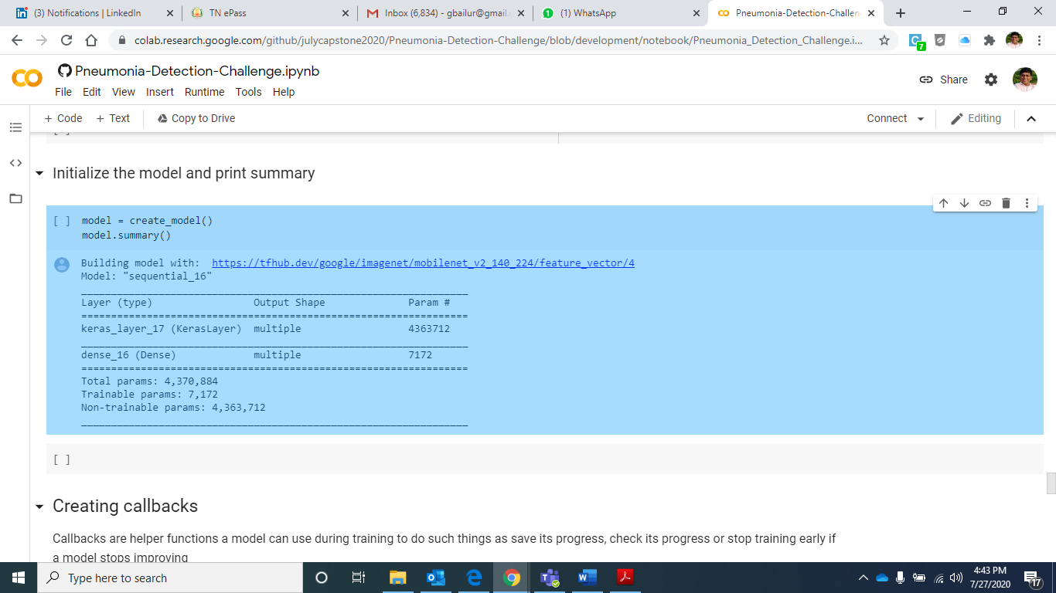

**Defining callback:**

We have setup the Tensorboard feature to define the call back and below steps are taken to address them.

* Load the tensorboard notebook extension
* Create tensortboard callback – by which we will able to save logs to a directory and pass it to our model during fit
* To visualize our training logs we will use %tensorboard magic function

**Defining Early stopping:**

We have also defined early stopping to ensure we stop the process if there is a overfit scenario and/or loss value is not improving much. This way we will able to validate and re-run the model by changing right hyper parameter for better accuracy outcome.

**Running the model:**

We have set the epochs to 100 to start with and called the fit function to execute the model.. Below is our INTERIM Observation..

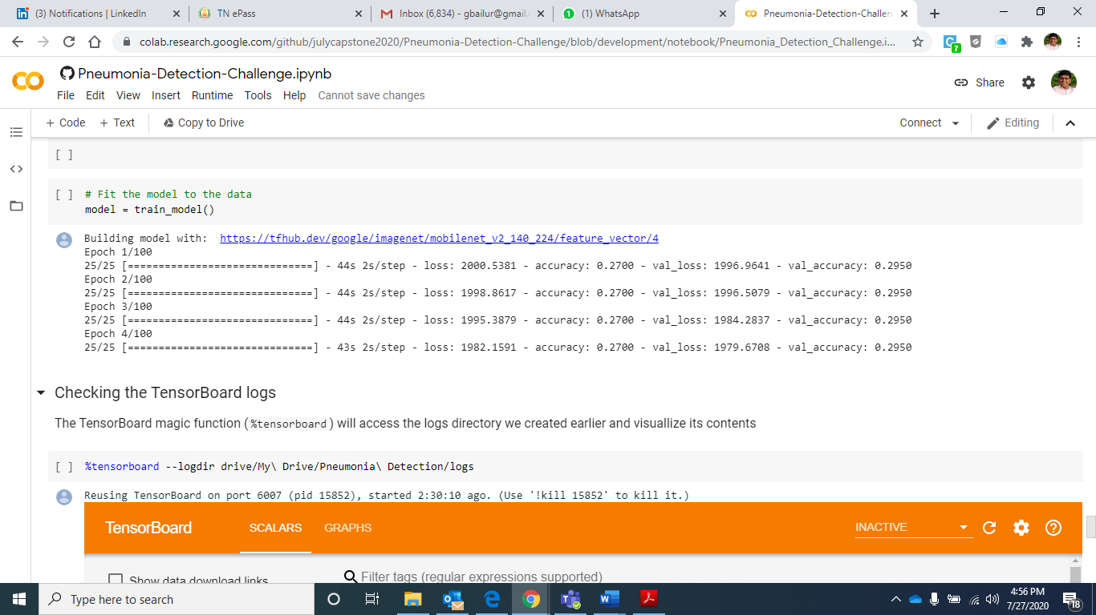

**Validating the logs:**

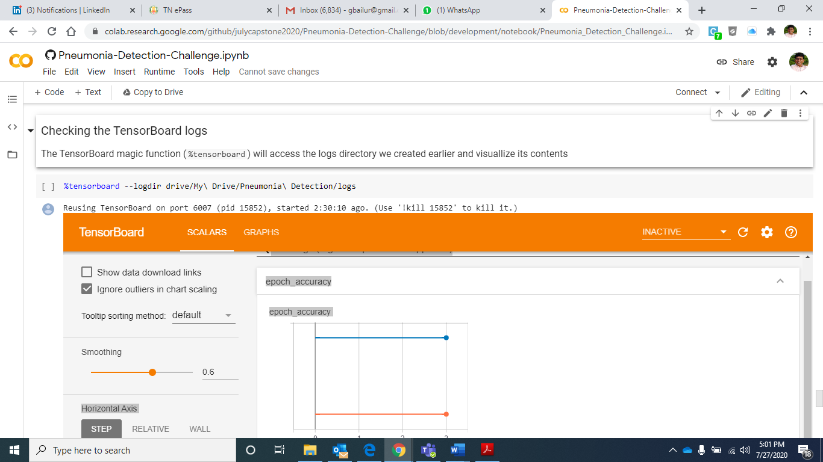

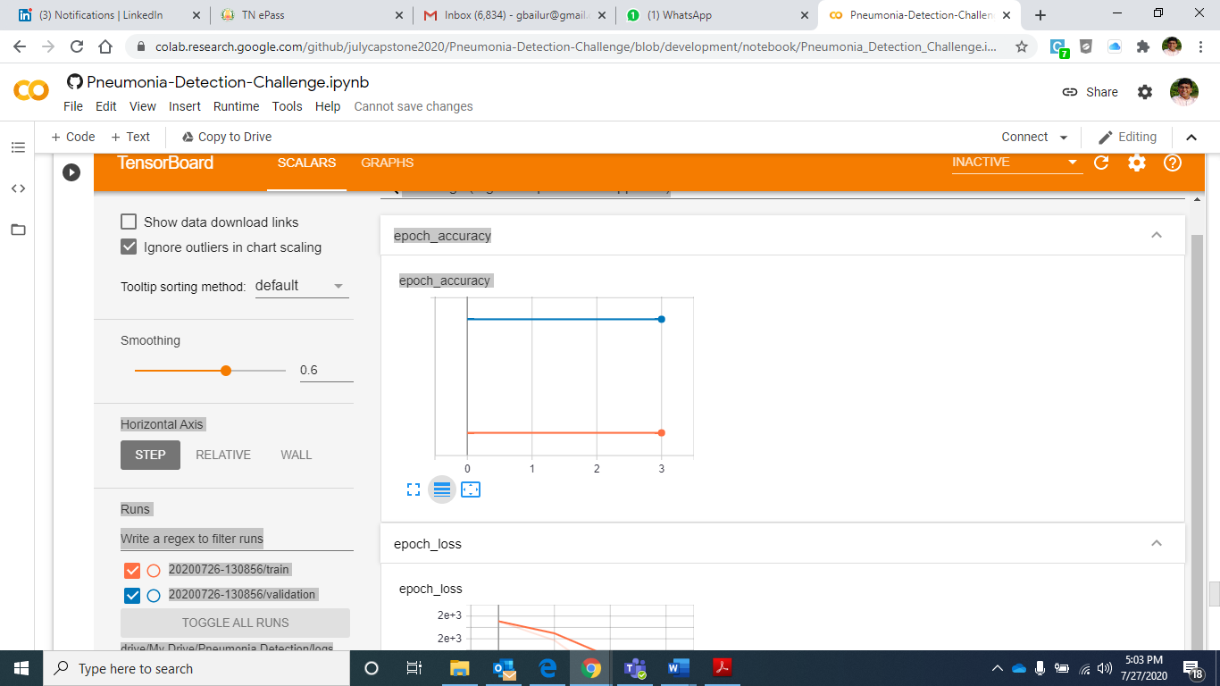

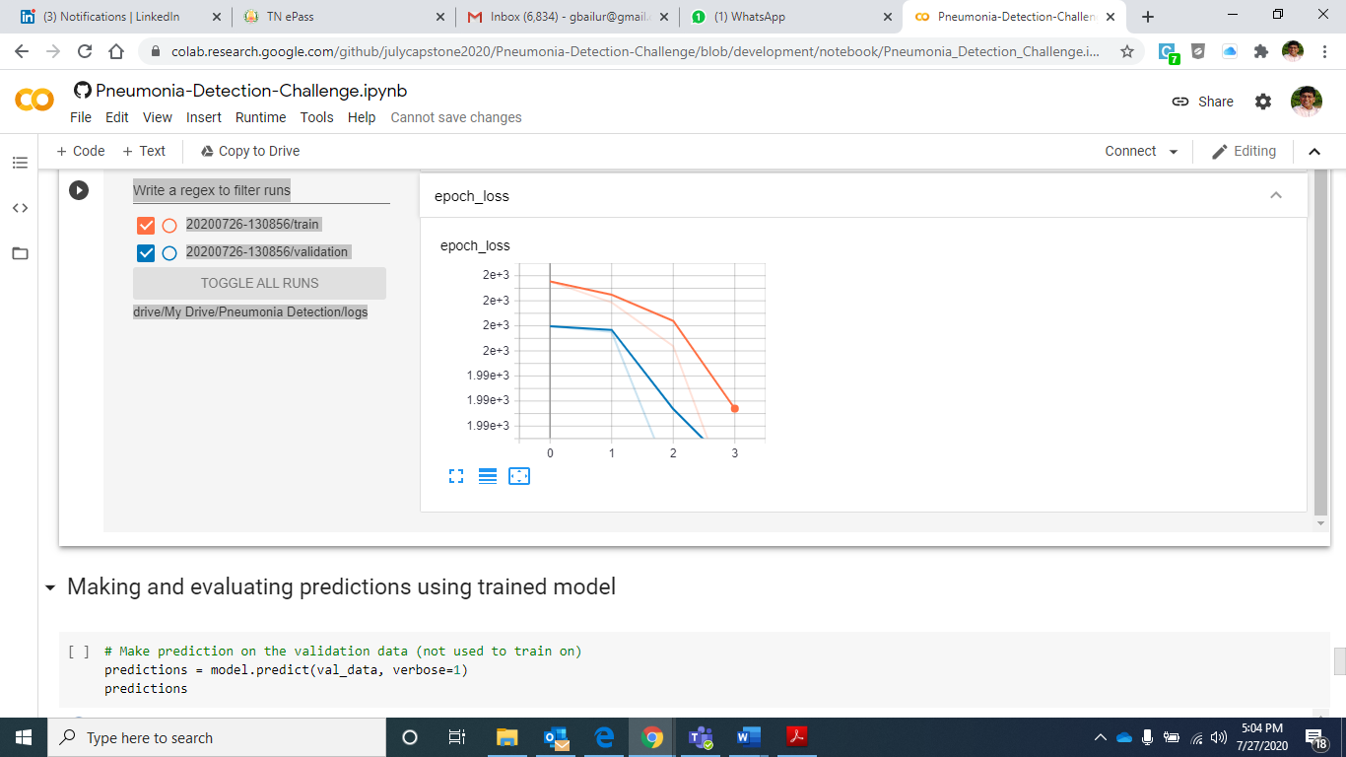

We did get into some of the challenges in progressing with the image translation and hence we observe high loss and very low accuracy to start with. We will continue further to address the challenges with the above approach to drive a very high accuracy when we finally conclude on this.

# Next steps and improvements.

As we continue further, our objective is to build the model with 4 different architectures by adopting the transfer learning techniques and we will continue to try on YOLO, SSD and Mask R-CNN along with Mobilenet..

Based on accuracy level and understanding the model behaviour further for each of them, In order to tune these models further – we will follow the below steps.

* Adding a layer in addition to what the model provides
* Validating the hyperparameters based on the results to drive the improvement in accuracy
* Trying different loss function and optimizers to see where things can be improved.